# The Carbon Cycle

|  |  |
| --- | --- |
| Name: |  |
| Class: |  |
| Period: |  |
| Date: |  |

Carefully read each question and then circle the letter of the correct answer.

1. Recall the percentage of the atmosphere that is carbon dioxide.
   1. 0.004%
   2. 0.04%
   3. 0.4%
   4. 4%
2. **Note: this question has two parts, be sure to answer both!**

Layla is reviewing notes on photosynthesis and respiration passed to her by her friend Abe. She sees that photosynthesis and respiration involve the same molecules: water, carbon dioxide, glucose and oxygen. She decides that they must be the same process.

Decide whether Layla is correct.

* 1. Layla is correct
  2. Layla is incorrect

Select the option that best justifies your reasoning.

1. Photosynethesis uses carbon dioxide and water to produce glucose and oxygen, whereas respiration uses glucose and oxygen to produce carbon dioxide and water.
2. Photosynthesis uses carbon dioxide and oxygen to produce water and glucose, whereas respiration uses carbon dioxide and water to produce glucose and oxygen.
3. Both processes use carbon dioxide and water to produce flucose and oxygen.
4. Both proceseses use water and oxygen to produce glucose and carbon dioxide.
5. Select all the consequences of increasing carbon dioxide emissions below. Select ALL correct options.
   1. Reduced respiration
   2. Ocean acidification
   3. Melting permafrost
   4. Rising global temperature
6. Describe the effect on the ocean from an increase in carbon dioxide in the atmosphere.
   1. Carbon dioxide bubbles dissolve in the ocean where they are stored, making it more basic.
   2. Carbon dioxide is taken up by the plants on land for photosynthesis, so does not affect the ocean.
   3. Carbon dioxide dissolves in the ocean, forming carbonic acid and making it more acidic.

Select the correct words to fill in the spaces below.

**Glucose ATP Respiration Photosynthesis Carbon dioxide**

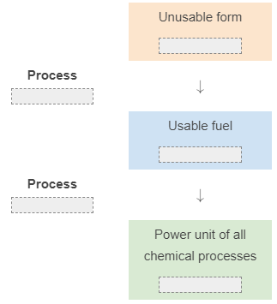

**Pool 40% charcoal reservoir 80% limestone**

Carbon is stored in many places. For example, it is stored in the living mass of trees in the forests of the world. With a number of 247 billion tonnes of carbon, forests are a significant carbon ______________. However, the top prize for carbon storage would go to ___________ which is formed from seashells in the ocean source. It makes up ____________ of global carbon!

Stored in the animal or used for growth

Transformed into carbon dioxide which is released into the atmosphere

Released into the atmosphere from the combustion of the fuel.

Transformed into oil, coal or natural gas stored below Earth’s surface.

Transformed into carbon dioxide which is released into the atmosphere.

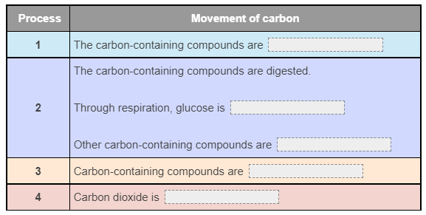

**forests photosynthesis crops**

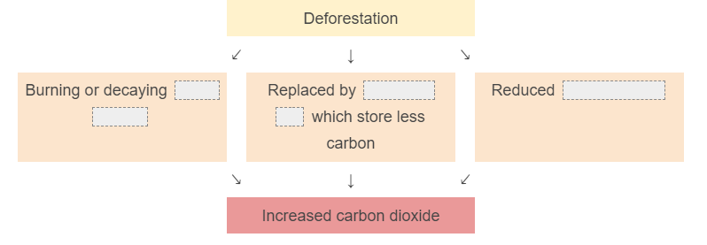

**Transportation Land Use Fossil Fuel Consumption Manufacturing**

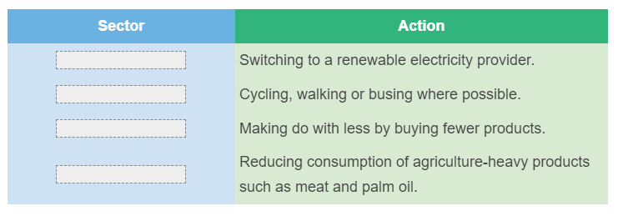

Short Answer

1. The diagram below shows a partially completed diagram of the carbon cycle.

Draw at least two arrows that show the movement of carbon.

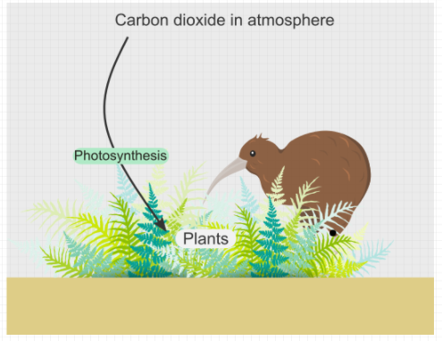

1. Think of a specific example, and describe how carbon is cycled throughout the Earth. Be sure to specify what form carbon is in.

When you describe a person, object, event, or situation, you say what they are like or what happened.

Here are a few suggestions if you are stuck for ideas:

* Pet plants or animals.
* Your favourite animal.
* A community garden.
* A destination you’d like to travel to one day.

You can use the diagram below as a guide.

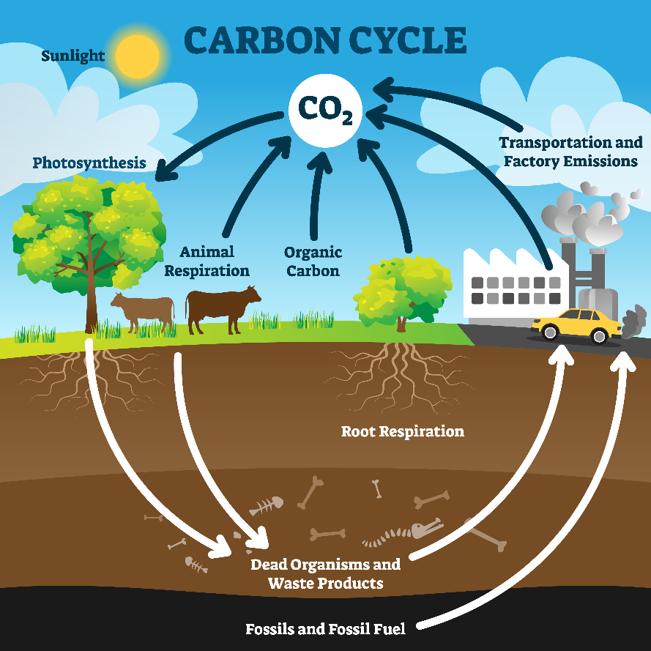

1. This graph breaks down the global greenhouse gas emissions for the year 2016.

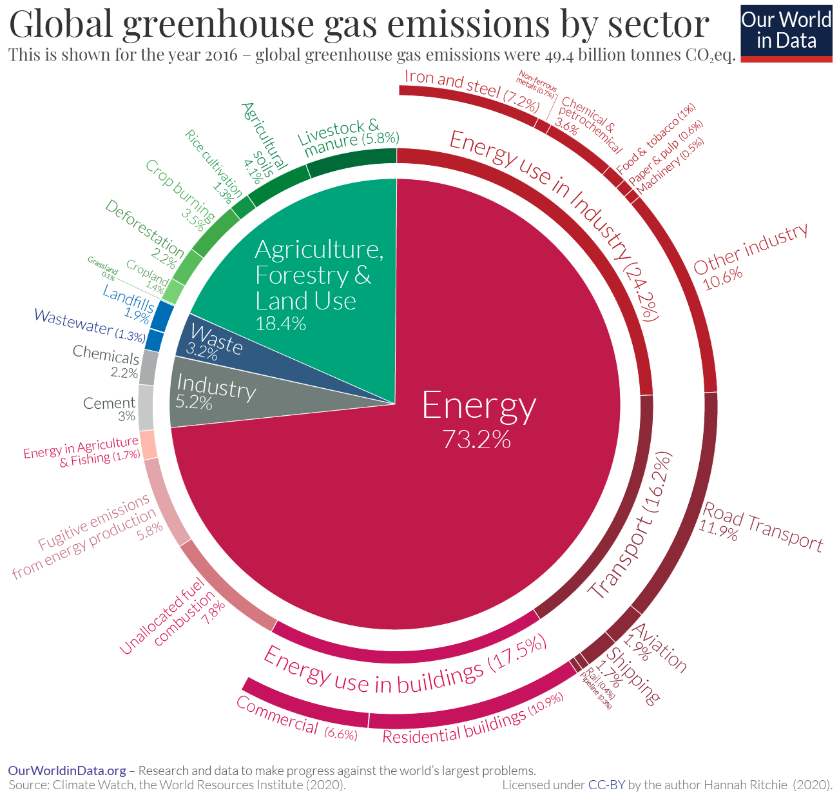

Identify the sector that emits the most greenhouse gases.

1. Agriculture, Forestry and Land Use
2. Energy
3. Industry
4. Waste

Energy for transport creates 16.2% of the total greenhouse gas emissions.

Identify the type of transport that emits the most greenhouse gases.

1. Rail
2. Shipping
3. Road transport
4. Aviation

Propose one action you could take to reduce your greenhouse gas emissions from transport.

Glossary

**Decomposer Respiration Carbon cycle Photosynthesis**

